Mitochondrial DNA Tracks the Spread of Linguistic Structures Through Unrelated Languages in Africa and Eurasia

Abstract: Language families are groupings of languages based on shared vocabulary innovations. They are useful for demonstrating cultural relatedness of populations, and hence overlap to some extent with the distribution of genetic markers. This paper shows that abstract properties of languages such as grammatical features or phonemes also correlate with genetic markers, after controlling for known language families. Linguistic structures can remain unchanged in language families over thousands of years, but are also crucially borrowed across language families in ways corresponding to gene flow between populations. Mitochondrial DNA haplogroups can explain the distribution of structures in unrelated languages, and also provide evidence for events beyond the reach of current linguistic reconstruction, such as the arrival of languages in North Africa from Eurasia in the early Neolithic.

One Sentence Summary: Mitochondrial DNA haplogroups can predict structural properties of unrelated languages, and push reconstruction of language history beyond the limits of established language families.

Main Text: Genes and languages can often travel together, when people migrate to new regions and bring languages with them. Y chromosome and mitochondrial DNA haplogroups in particular are therefore often compared in their distribution to language families (1). This paper investigates a different side of language history: the way that structural properties of languages can be conserved in language families, and also travel between them. Abstract properties can travel between languages in a way analogous to gene flow between populations. For example, Vietnamese became a tonal language (using pitch to distinguish different words) under the influence of Chinese, despite the fact that they are unrelated (2). Similarly, some Bantu languages acquired click sounds from neighbouring San languages (3). This process, called ‘language contact’, raises the question of whether grammatical and phonological properties travel with genes. There is some evidence that linguistic structures are stable and distinctive enough over time to be informative about population history (4). The question is whether the distribution of these structures in unrelated languages can be explained by the movement of people between populations, perhaps of specific lineages that can be tracked by Y chromosome or mitochondrial DNA.

An example is how languages vary in the complexity of consonant clusters, from Georgian which allows words such as mtsvane, to Japanese which mostly only allows consonant-vowel combinations such as hajimaru ‘begin’. Rules for how many consonants are allowed can travel between languages; for example, Chinese or Malay speakers in Singapore learn English and simplify some consonant clusters such as lisp to lis (5), because Chinese and Malay lack these consonant clusters. Conversely, some second-language learners can complexify the language that they are learning. Moroccan Arabic has developed consonant clusters by deleting vowels, such as changing Standard Arabic kitabtu to ktebt, and this is likely to be under the influence of Berber languages which themselves allow very complex consonant clusters (6).

When a population adopts a new language, as in the above cases, they may therefore change that language according to the structures of the language that they used to speak. This process is called ‘substrate influence’. This means that mitochondrial DNA haplogroups might be especially likely to be predictors of syllable structures, because of the finding by Forster and Renfrew that languages are often brought by a small group of men into a new region, making language families correlate with Y chromosome haplogroups, while mtDNA haplogroups typically reflect populations already in the region, who would speak a ‘substrate’ language (1). In cases such as English being adopted by Chinese speakers in Singapore, then it is the languages of the substrate population (Chinese and Malay) which are predicted to influence the syllable structure of the superstrate language (English). Syllable structures may sometimes be a trace of languages that used to be spoken in regions before the arrival of new languages, and hence show another side of linguistic history resembling that shown by mitochondrial DNA.

If particular syllable structure rules are found across several language families, then they may correlate with the distribution of specific mitochondrial DNA haplogroups. This hypothesis was tested on 73 populations in Africa and Eurasia up to the Pacific, from twenty-six different language families. Population frequencies of 252 haplogroups were collected from genetics literature on these populations (7-20), ranging from the most general, such as haplogroup M which is found everywhere outside of Africa, to the most specific haplogroups for which there is data such as Bc41b. Three syllable structure features were tested (how many consonants are allowed at the beginning of a syllable, how many at the end, and how many tones are used), using data from an independently coded database (21). These three syllable features were tested in linear regressions with all 252 haplogroups. The way to correct for multiple testing was to take the p-values of all the linear regressions and find how many p-values were in between 0 and 0.05 compared with p-values in other intervals (e.g. between 0.4 and 0.45). If there are genuine correlations between consonant cluster complexity and haplogroups above that expected by multiple testing, then there should be many more below p-values below 0.05 than in other intervals. This pattern holds for the real data, and does not hold for a random arrangement of the data (figures S1-S2). All three syllable features show more significant correlations than expected by chance; for example, coda complexity correlated significantly (p<0.05) with 77 haplogroups, compared with 28 by the interval with the second greatest number of correlations (0.3<p<0.35). Mixed effects models were then used with language family as a random intercept, and in all three cases there were more significant correlations than expected by chance. A different way of avoiding multiple testing was to use a Mantel test of overall genetic distance between populations and differences in syllable structures, the results of which were significant for coda complexity (r=0.35, p=0.001) and number of tones (r=0.2, p=0.03) but not onset complexity (p=0.17); using partial Mantel tests one can also simultaneously control for language family and geographic distance, for which the results are still significant (coda complexity r=0.14, p=0.003; number of tones r=0.18, p=0.008). Genetic distance in fact correlates with these features better than language families do (r=0.14 for coda complexity and r=0.15 for number of tones).

Having established that there are real correlations between syllable structures and mtDNA haplogroups, the strongest correlations can be chosen to see whether particular population movements may be responsible for the spread of particular structures. The strongest correlation is between coda complexity and haplogroup HV (R²=0.34, p=3.8e-08), a correlation that is significant after a Bonferroni correction for the 756 tests done. Haplogroup HV is a large haplogroup found in Europe, North Africa, and decreasing in frequency in eastern Eurasia (Fig. 1). This distribution is similar to the distribution of languages that allow complex consonant clusters in the coda of syllables (Fig. 2).

Why might the distributions in the two maps be similar? The first reason is because of known relatedness of languages: for instance, English and German both have complex syllables, and speakers of these languages have high frequencies of haplogroup HV. This shows that syllable structure is fairly stable within language families such as Indo-European; but the question is whether this correlation holds beyond that expected because of known language families. In order to answer this, a mixed effects model with haplogroup HV frequency and random intercepts for language family was used, which predicted coda complexity significantly better than a model with just random intercepts for language family (χ²=5.39, p=0.02). A second method was to randomly sample one language per known language family and retest the correlation between haplogroup HV and coda complexity, which was significant in 49% of the random samples. Haplogroup HV also correlates with other syllabic features such as the complexity of syllable onsets (R²=0.19, p=7.4e-05) and inversely with the number of tonal distinctions (R²=0.13, p=0.013), and both are similarly significant in mixed effects models (p<0.05).

This result mainly shows that complex consonant clusters have been traveling between language families in Eurasia such as Indo-European, Uralic, Northwest Caucasian, Basque and Dravidian along a similar path to the spread of haplogroup HV, either because these language families have been in contact, or in some cases because they may be distantly related. Unexpectedly, complex syllables and haplogroup HV also show a similar distribution within Africa. Haplogroup HV correlates significantly within African languages taken by themselves with coda complexity (R²=0.67, p=0.015) and inversely with number of tonal distinctions (R²=0.78, p=0.006), although not with onset complexity (R²=0.34, p=0.1). On an expanded sample of 13 African languages for which haplogroup HV data was available (22), all three of these correlations with haplogroup HV were significant (e.g. with codas, R²=0.82, p=2e-05). This suggests that the presence of these complex consonant clusters in North African languages is not a random independent development, but connected to the presence of haplogroup HV. The highest frequencies of HV and the most complex syllables are found in North Africa in Berber populations of Morocco and Algeria. The syllable complexity of Berber languages has nothing to do with Indo-European influence (such as the French colonization of Morocco), because Berber languages allow syllables typically more complex than those found in Indo-European languages (often even without any vowels such as tkst 'you feed on'), and primarily in indigenous words that are not known to be borrowed or influenced by any Indo-European language (23). Instead, Berber languages seem to have a Eurasian affinity, in the same way that Berber populations have high frequencies of Eurasian mtDNA haplogroups (e.g. haplogroup U and haplogroup J, which also correlate with complex codas). Eurasian gene flow into North Africa from the Near East or Iberia during the early Neolithic (24) may similarly have brought complex codas from Eurasia in North Africa. Since Berber is a branch of the Afro-Asiatic family, this would either suggest that Afro-Asiatic languages may have originated in Southwest Asia, or that complex syllables came into this branch of Afro-Asiatic by substrate influence. In either scenario, it is linguistic evidence for Neolithic Eurasian migration into North Africa, for which there is clear archeological and genetic evidence, but which has so far been lacking in linguistics (25).

Mitochondrial DNA haplogroups were then compared with data on phonemes (26) and word orders (27), which both showed more significant correlations than expected by chance. The word order that showed the most significant correlations with mtDNA was the order of numeral and noun, which may be because numerals have been found to be among the most stable words in the lexicon (28). Numerals such as ‘two’ and ‘five’ are cognate across all branches of Indo-European, and this stability may be why numeral word order (preceding the noun in the phrase ‘two people’) is also almost invariant across Indo-European languages, in contrast with other word orders such as that of verb and object, which vary between even closely related languages such as English and German (27). Numeral-noun order correlates in a logistic regression with Eurasian haplogroups such as HV (p=0.001) and U (p=0.0003) in particular, and is the word order found in Berber languages and related Afro-Asiatic languages in Egypt, providing additional support for their Eurasian affinity (Fig. 3). The correlation with haplogroup U, although not with haplogroup HV, in addition holds up within African languages by themselves (p=5.9e-06);

Genetic variants such as mitochondrial DNA haplogroups thus have the power to explain why some languages have more complex consonant clusters than others, and in some cases are better predictors of these traits than known language families are. The results also show that individual structural properties of languages can be distinctive and durable, and can spread in a meme-like way through unrelated languages, in ways closely correlating with the spread of individual genetic variants through neighboring populations. When treated as analogous to genetic variants, the distributions of linguistic structures hold promise for showing the way that populations have been spreading and interacting in prehistory.

References and Notes:
- P. Forster, C. Renfrew, Mother tongue and Y chromosomes. Science 333, 1390-1391 (2011)
- N. J. Enfield, Areal linguistics and mainland Southeast Asia. Annual Review of Anthropology 34, 181-206 (2005)
- C. Barbieri, A. Butthof, K. Bostoen, B. Pakendorf, Genetic perspectives on the origin of clicks in Bantu languages from southwestern Zambia. Eur. J. Hum. Genet. 21, 430-436 (2013)
- M. Dunn, A. Terrill, G. Reesink, R. A. Foley, S. C. Levinson, Structural phylogenetics and the reconstruction of ancient language history. Science 309, 2072-5 (2005)
- L. Lim, Ed., Singapore English: A Grammatical Description. (John Benjamins, Amsterdam, 2004)
- U. Maas, in J. Owens, Ed., Arabic as a Minority Language. (Mouton de Gruyter, New York, 2000) 383-404
- C. Barbieri et al., Ancient substructure in early mtDNA lineages of Southern Africa. Am. J. Hum. Genet. 92(2), 285-292 (2013)
- C. Barbieri et al., Contrasting Maternal and Paternal Histories in the Linguistic Context of Burkina Faso. Mol. Biol. Evol. 29(4), 1213-1223. (2012)
- M. Derenko et al, Phylogeographic analysis of mitochondrial DNA in Northern Asian populations. Am. J. Hum. Genet. 81(5), 1025-1041 (2007)
- A. T. Duggan et al., Maternal History of Oceania from Complete mtDNA Genomes: Contrasting Ancient Diversity with Recent Homogenization Due to the Austronesian Expansion. Am. J. Hum. Genet. 94(5), 721-733. (2014)
- S. A. Federova et al., Analysis of Mitochondrial DNA Lineages in Yakuts. Molecular Biology 37, 544-553 (2003)
- A. Helgason et al., mtDNA and the Islands of the North Atlantic: Estimating the Proportions of Norse and Gaelic Ancestry, Am. J. Hum. Genet. 68, 723-737 (2001)
- T. Kivisild et al., The Genetic Heritage of the Earliest Settlers Persists Both in Indian Tribal and Caste Populations. Am. J. Hum. Genet. 2(2), 313-332 (2003)
- M. S. Peng et al., Tracing the Austronesian Footprint in Mainland Southeast Asia: A Perspective from Mitochondrial DNA. Mol. Biol. Evol. 27(10), 2417-2430 (2010)
- S. Plaza et al., Joining the Pillars of Hercules, mtDNA Sequences Show Multidirectional Gene Flow in the Western Mediterranean, Ann. Hum. Genet. 67, 312-328 (2003)
- L. Quintana-Murci et al., Where west meets east: the complex mtDNA landscape of the southwest and Central Asian corridor. Am. J. Hum. Genet. 74, 827–845 (2004)
- E. B. Starikovskaya et al., Mitochondrial DNA diversity in indigenous populations of the southern extent of Siberia, and the origins of Native American haplogroups. Ann. Hum. Genet. 69, 67-89 (2005)
- M. Tanaka et al., Mitochondrial genome variation in eastern Asia and the peopling of Japan. Genome Res. 14, 1832–1850 (2004)
- B. Wen et al., Genetic Structure of Hmong-Mien Speaking Populations in East Asia as Revealed by mtDNA Lineages. Mol. Biol. Evol. 22(3), 725-734 (2005)
- B. Yunusbayev et al., The Caucasus as an asymmetric semipermeable barrier to ancient human migrations. Mol. Biol. Evol. 29(1), 359-365 (2012)
- M. Donohue, R. Hetherington, J. McElvenny, V. Dawson, World Phonotactics Database. 2013. Department of Linguistics, The Australian National University (2013) http://phonotactics.anu.edu.au. Accessed 1/10/2014.
- D. A. Badro et al., Y-Chromosome and mtDNA Genetics Reveal Significant Contrasts in Affinities of Modern Middle Eastern Populations with European and African Populations. PLoS ONE 8(1), e54616. (2013)
- R. Ridouane, Syllables without vowels: phonetic and phonological evidence from Tashlhiyt Berber. Phonology 25, 321-359 (2008)
- H. Ennafaa et al., Mitochondrial DNA Haplogroup H Structure in North Africa. BMC Genetics 10, 8 (2009)
- P. Bellwood, First Migrants: Ancient Migration in Global Perspective. (Wiley, 2013)
- S. Moran, D. McCloy, R. Wright, Eds. PHOIBLE Online. (Max Planck Institute for Evolutionary Anthropology, Leipzig, 2014)
- M. S. Dryer, M. Chapters 82-83 and 85-90, in M. S. Dryer, M. Haspelmath, Eds., The World Atlas of Language Structures Online. (Max Planck Institute for Evolutionary Anthropology, Leipzig, 2013).
- M. Pagel M, Q. D. Atkinson, A. Meade, Frequency of word use predicts rates of lexical evolution throughout Indo-European history. Nature 449, 717-720 (2007)
- H. Hammarström, R. Forkel, M. Haspelmath, S. Nordhoff, Glottolog 2.0. (Max Planck Institute for Evolutionary Anthropology, Leipzig, 2014).
- M. van Oven, M. Kayser, Updated comprehensive phylogenetic tree of global human mitochondrial DNA variation. Hum. Mutat. 30(2), E386-E394. (2009) http://www.phylotree.org.

Acknowledgements: Thanks to D. Dediu, M. Dunn, N. Enfield, S. Graham, R. Hunsucker, S. Levinson, P. Muysken, E. Ritten, S. Roberts, and K. Smiet for feedback. This work is supported by the Centre for Language Studies, Radboud University, Nijmegen.

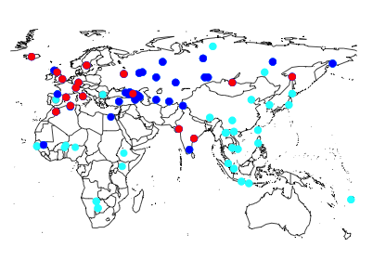

Fig. 1. The spread of complex syllables: languages in red allow three or more consonants in the coda of syllables; languages in dark blue allow two consonants; languages in light blue allow fewer than two consonants.

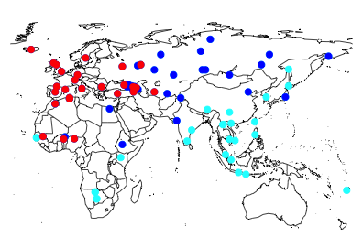

Fig. 2. The spread of haplogroup HV: populations in red have a population frequency of haplogroup HV above 30%; populations in dark blue have a frequency above 0%; and populations in light blue do not have haplogroup HV.

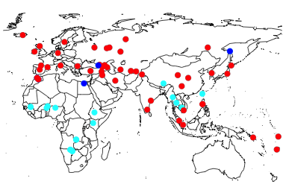

Fig. 3. The spread of numeral-noun word order: languages in red place the numeral before the noun; languages in dark blue have the option of placing the numeral before the noun; and languages in light blue place the numeral after the noun.

Supplementary Materials:

Materials and Methods

Figures S1-S8

Tables S1-S8

Supplementary Materials:

Material and Methods

This paper tests the relationship between syllable structures and mitochondrial DNA haplogroups in Africa and Eurasia. The paper focuses on Africa and Eurasia, in part because of the availability of extensive genetic data for which there is matching linguistic data. It is also to constrain the focus of interactions between language families to within the last ten thousand years, during which it is unlikely that there has been pre-colonial linguistic interaction with languages in the Americas or Australia.
A consensus on language family classification was followed using Glottolog (29). Languages were assigned a geographical coordinate provided by the World Phonotactics database (21), or the World Atlas of Language Structures (27) in the case of word order.
Data on syllable structure was taken from the World Phonotactics Database (21). Three properties were coded for: the number of consonants allowed in the onset of a syllable, the number of consonants allowed in the coda, and the number of tones.
The coding in the database is based on native vocabulary rather than loan-words. Some languages are coded as having consonant clusters despite this being restricted (such as only being able to add -s). Other potential issues of coding are the way that semi-vowels and glides are counted. For the sake of consistency, the coding in the database was taken as it is, without changing any of the coding, although in some cases the coding could be disputed.
Data on haplogroups was taken from papers on mitochondrial DNA (7-20). This data is summarized in table S1. The populations were then compared using 252 haplogroups. These ranged from the most general to the most specific. The frequencies of each haplogroup were calculated using table S1 and Phylotree (30), the phylogeny of mitochondrial DNA haplogroups which is summarized in Newick tree format in table S2 (dummy nodes are included in order to make it readable in the R ‘ape’ package, which does not read trees with singleton nodes). If there is a specific haplogroup present in a population, then the haplogroups of which it is a sub-clade are also counted as being in that population. For example, if there is 20% haplogroup H1 and 10% haplogroup H2, then the total frequency of haplogroup H in the population is 30%. The resulting table of populations with frequencies for each of the 252 haplogroups is given in table S3, along with data on syllable structure.
Statistical analysis was carried out using R. The method was to test all three syllable structure features against all 252 haplogroups. This may seem like multiple testing, but it is justified because it is not know in advance which haplogroups will have carried distinctive syllable structures. The method of correcting for multiple testing was to compile the p-values of all the tests performed into a histogram, and to see how many p-values were below 0.05. In purely random data, the number of p-values below 0.05 would not be any higher than p-values in other intervals. For example, the histogram in figure S1 is generated using a purely random arrangement of the coda data and then tested against the 252 haplogroups. The bar representing the number of p-values below 0.05 is not higher than the bars representing p-values in other intervals. By contrast, using the actual coda complexity data produces the histogram in figure S2, in which the number of p-values below 0.05 is clearly higher than the number of p-values in other intervals. The second greatest number of p-values is in the range 0.3<p<0.35. There are 77 correlations with p-values below 0.05 compared with 28 in the interval 0.3<p<0.35, suggesting that at least 49 correlations are genuine rather than merely due to multiple comparisons. Onset complexity and number of tones also showed this pattern.
This method is only able to show that there are genuine correlations in the data, not which ones are genuine and which ones are spurious. The next step is to look at the strongest correlations, in particular any one which survives a Bonferroni correction for the number of tests done. One correlation which survives a Bonferroni correction for the 756 tests done is the correlation between coda complexity and haplogroup HV (p=3.8e-08).
A different method was to use a Mantel test of overall genetic distance and difference in syllable complexity. In this case genetic distance was calculated simply as difference in frequencies of each haplogroup, without taking into account number of mutations each haplogroup differed by (as AMOVA would do). The reason for this is that populations such as Khoisan populations would be very distant genetically from all other populations if mutational differences between Khoisan mtDNA haplogroups and other haplogroups were taken into account.
Mixed effects models were then tested to see if the correlations were purely due to non-independence of languages within known families. For each haplogroup coda complexity was tested in a mixed effects model with the haplogroup frequency and using language family as a random intercept. This mixed effects model was then compared to a model using just language family as a random intercept. These two models were then compared using the ANOVA function, and a p-value is given for whether the model with haplogroup frequency is significantly better than the model without. This was done for all 252 haplogroups, and the p-values compiled into a histogram, shown in figure S4. The number of p-values below 0.05 was again much higher than for other values, except for the interval between 0.95 and 1. This was also true when done for onset complexity and number of tones. The interval of 0.95<p<1 can be ignored because these p-values probably represent tests for which there is low data. This pattern was also found for onset complexity and number of tones, shown in figure S5. In all three cases the number of p-values below 0.05 is otherwise much higher than the p-values in other intervals.
Coda complexity correlates the strongest with haplogroup HV, plotted in figure S6. In order to investigate whether this was due to known language families, a mixed effects model was used and found to be significantly better than a model without haplogroup frequency as a fixed effect (χ²=5.39, p=0.02). Another way of controlling for the non-independence of related languages was to sample one language per family. In this case the correlation was significant 49% of the time, which is sufficiently above chance to show that there is a correlation after controlling for language family.
A Mantel test was done to see whether haplogroup HV and coda complexity correlated simply because they both correlate with geography. Distances between populations were calculated using the latitude and longitude of each population and the Haversine formula. The test was still significant controlling for both distance and language family (r=0.21, p=0.001), suggesting that the correlation is not simply due to the fact that both traits correlate with geography.
Word order features and phonemes were subsequently tested, using data from two independently coded databases (26,27). Six different word orders were used: the order of subject and verb, object and verb, genitive and noun, adjective and noun, numeral and noun, demonstrative and noun, and relative clause and noun. These word orders features were split into three and binarised, namely whether they had placed the first element before the second, the second element before the first, or whether they allowed both orders; for instance, if a language places the numeral exclusively before the noun, then it will be coded as having 1 for numeral-noun order, 0 for noun-numeral order, and 0 for having both numeral-noun and noun-numeral orders. If a language allows both orderings, then it will be coded as having 0 for numeral-noun order, 0 for noun-numeral order, and 1 for having both. This resulted in 18 different features, which were tested against all 252 haplogroups again. It should be pointed out that these word order features are non-independent, both because having a value of 1 for one feature means that it has a value of 0 for the other two related features (e.g. having 1 for numeral-noun means that it has 0 for noun-numeral and 0 for both orderings), and because certain word orders may be mutually interdependent such as verb-object order and other word orders (27). 1638 different phonemes were used from the PHOIBLE database, summarized in table S5. Since the languages in these databases were different from the languages analyzed for the syllable structure data, they were assigned populations with genetic data summarized in tables S4 and S6 respectively.
The same multiple testing method was used for word orders and phonemes. Word orders showed the same pattern as syllable structures in correlating with mtDNA haplogroups, although numeral-noun order was the only feature which showed this pattern individually (figure S7). Phonemes did not show this pattern initially, instead showing many correlations with high p-values (figure S8). This is probably due to low data for some very rare phonemes and haplogroups. When phonemes and haplogroups which are found in less than 10% of the sample are excluded, then there are more phoneme-haplogroup correlations than expected by chance, as shown in the second histogram of figure S8.
In the extended African sample, a paper with information on haplogroup HV in different African populations was used (24). The paper does not give detailed linguistic information on the samples, instead giving the country which the samples are from. In order to assign a language to each sample, a median value was taken from each country; for example, the median number of consonants allowed in the onset in languages in Egypt is 1. The capital of the country was used to represent the location of the sample. Table S7 and table S8 summarize this data for syllable structure and numeral-noun order respectively. The correlation between haplogroup HV and numeral-noun ordering within African languages was tested but found to be not significant (p=0.3).
The frequency of HV in the populations in that paper was given, as was the frequency of haplogroup H. To get the actual frequency of macro-haplogroup HV, however, these two frequencies have to be added together, as in their paper HV means having HV but not having H.

Supplementary Figures S1-S8:

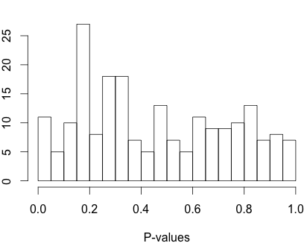
Figure S1: histogram of p-values of a random arrangement of the coda complexity data against all 252 haplogroups. Some tests have p-values below 0.05, but no more than have p-values in other intervals (e.g. the most is 0.15<p<0.2), suggesting that significant correlations in this data are purely due to multiple testing.

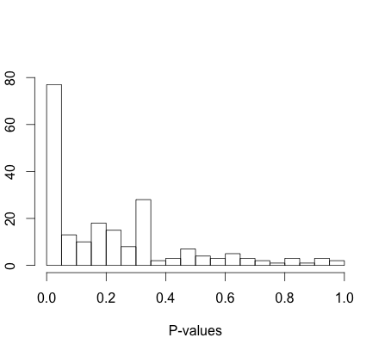

Figure S2: the histogram generated from comparing coda complexity with all 252 haplogroups. In this data, there are genuine correlations between coda complexity and some haplogroups, as shown by the fact that there are many more correlations with p-values below 0.05 than with p-values in other intervals.

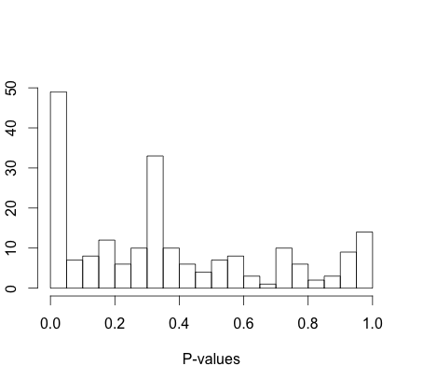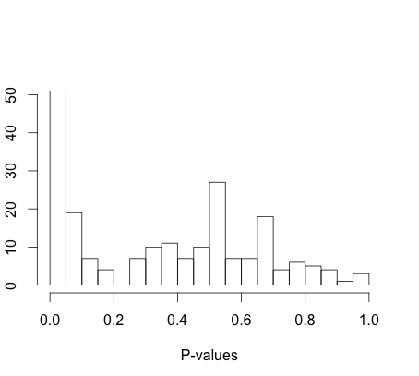

Figure S3: onset complexity and number of tones.

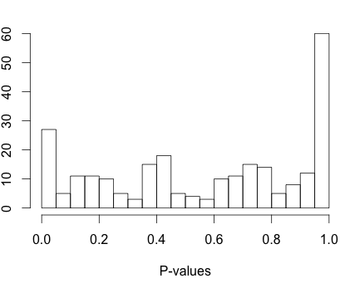

Figure S4: mixed effects models for coda complexity

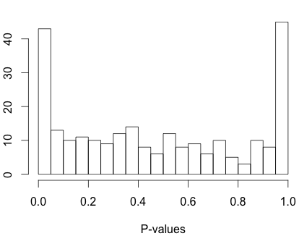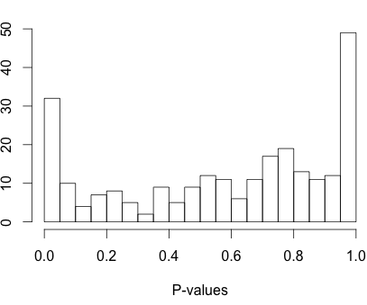

Figure S5: mixed effects models for onset complexity and number of tones.

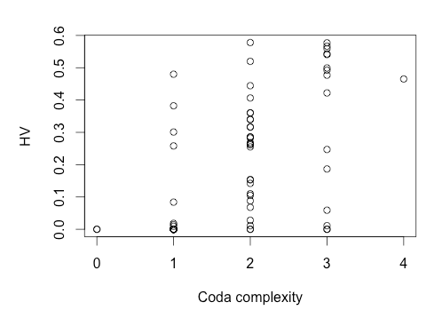

Figure S6: plot of coda complexity (number of consonants allowed in the coda of syllables) against haplogroup HV frequency.

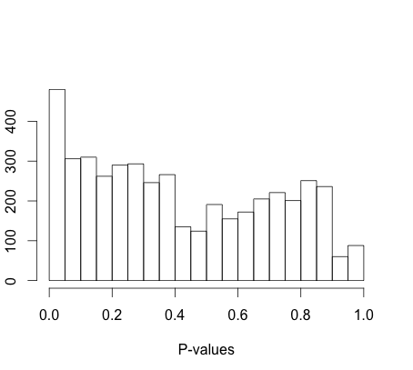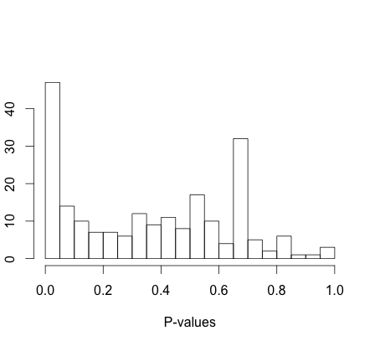

Figure S7: word orders and numeral-noun order in particular.

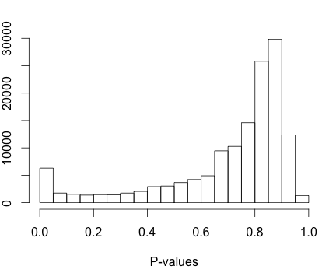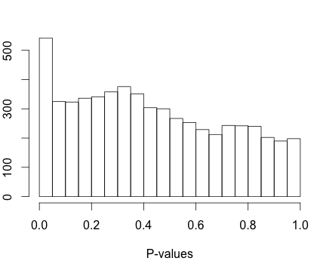

Figure S8: all phonemes and haplogroups, and all phonemes and haplogroups found in at least 10% of the populations.

